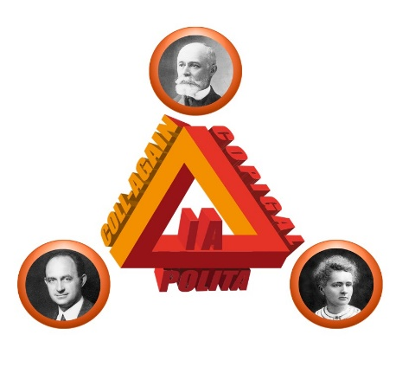

**Third Circular**

Joint LIA COLL-AGAIN, COPIGAL, and POLITA Workshop

French-Italian-Polish Collaborations

**March 5 - 7, 2019**

followed by the Joint Meeting of Steering Committees

**on March 8, 2019**

**Heavy Ion Laboratory, University of Warsaw, Poland**

Dear Colleagues,

The third joint Workshop of the COLL-AGAIN (France-Italy), COPIGAL (France-Poland), and POLITA (Italy-Poland) collaborations will be held in Warsaw at the **Heavy Ion Laboratory, University of Warsaw, from March 5 to March 7, 2019**. This Workshop aims at reinforcing existing collaborations and promoting new contacts and exchanges between the nuclear physics communities of the three countries.

The Workshop is organized jointly by:

Heavy Ion Laboratory, University of Warsaw, Poland

Institute of Nuclear Physics PAN, Krakow, Poland

Grand Accélérateur National d'Ions Lourds, Caen, France

Institut de Physique Nucléaire d’Orsay, Orsay, France

INFN Laboratori Nazionali di Legnaro, Legnaro, Italy

The Program of the Workshop can be found at:

<http://slcj.uw.edu.pl/en/lia/programme/>

REGISTRATION is closed now.

In particular cases please contact the organizers.

## PRACTICAL INFORMATION

## Location

## The Workshop will take place at the Heavy Ion Laboratory, University of Warsaw

## Address:

## ul. Pasteura 5A

## 02-093 Warszawa

## Poland

## Here are the instructions how to reach HIL:

## <http://slcj.uw.edu.pl/en/for-visitors/>

## Accommodation

## Rooms in the Hotel IBIS REDUTA have been reserved for the registered participants.

<https://www.accorhotels.com/en/hotel-7125-ibis-warszawa-reduta/index.shtml>

The hotel is located in a walking distance from the Heavy Ions Laboratory, which hosts the Workshop.

To reach the hotel from the airport one may take a taxi (approx. cost 20-30 PLN, ie 5-7 EUR).

**Meals**

Buffet **lunches** will be provided for participants from 5 to 7 of March at HIL. A **conference dinner** on Tuesday evening and a dinner on Wednesday evening just after the Poster Session will be organized.

**Conference fee**

The conference fee is 800 PLN.

(Conference fee for Invited Speakers, Members of the COPIGAL, COLL-AGAIN and POLITA Steering Committees, and active members of the Collaborations will be covered by the collaboration funds). Other participants can pay the fee at the registration desk (cash or credit card).

**Organizing committee (scientific coordinators of the three agreements)**

Bogdan Fornal IFJ PAN Krakow, Poland

Fabiana Gramegna INFN LNL Legnaro, Italy,

Marcella Grasso IPN Orsay, France

Marek Lewitowicz GANIL Caen, France

**Local organizing committee**

Krzysztof Rusek (Chair), Wojciech Piątek, Jolanta Matuszczak, Lidia Strzelczyk, Paweł Napiorkowski.

**Conference Secretary**

Justyna Samorajczyk (HIL UW), Małgorzata Niewiara (IFJ PAN)

We look forward to seeing you in Warsaw.

Bogdan Fornal, Fabiana Gramegna, Marcella Grasso, Marek Lewitowicz and Krzysztof Rusek